2022 Sweet Cream  www.paulasweet.com  www.etsy.com/shop/paulasweet  paulasweet@diganzi.com  Message phone +1-347-850-3502 | Invoice #
Purchaser information:  Recipient Name  Company Name  Street Address  City, ST ZIP Code  Phone: Phone | Ship To:  Recipient Name  Company Name  Street Address  City, ST ZIP Code  Phone: Phone
quantity | description | unit price | total
 | 4 oz. Sweet Cream original lemon/lavender ($34 + $3 to ship) | $ 37
 | 4 oz. Sweet Cream enzo patchouli/lavender ($34 + $3 to ship) | $ 37
 | 4 oz. Sweet Cream unscented fragrance free ($34 + $3 to ship) | $ 37
Credit card: use Etsy page https://www.etsy.com/shop/paulasweet
PayPal: remit to Linear Designs
Domestic shipping included - for international shipping, please inquire.
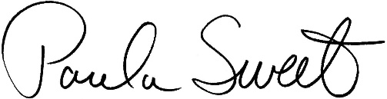

TOTAL due
If you have any questions concerning this invoice, contact information at top

Add any note you like here:

Thank you for your business!

